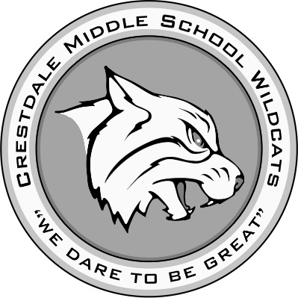
Crestdale Middle School Media Center

Battle of the Books Program

The purpose of the Battle of the Books (BOB) program is to encourage students to read. This is accomplished through exposure to quality literature by prominent authors representing a variety of literary styles. The BOB program was designed and is overseen by the North Carolina School Library Media Association; visit their website at www.ncslma.org for more information. The game-style competition format creates excitement and interest in reading, improving students’ reading skills and exposing them to literature that they might not choose on their own. The program is open to 6th, 7th, and 8th grade students.
Before making a commitment, it is important to understand what you will be asked to do. Beginning on September 15th, 2017, the BOB team will meet before school one day a week on Friday mornings to read and discuss books and practice answering trivia questions about them. Students will need to be available for these meetings each week from 8:00 to 8:50. The book list for the BOB program contains 27 books; team members are asked to read as many of the books as possible on the list in order to prepare for the competitions. This will require lots of extracurricular reading to be successful in this program. You can purchase your own copies of the books if you like, but there are also multiple copies in the media center available for checkout (and several are available as e-books). Purchasing the books is not required.
The county competition is held in early March 2018. All students who wish to participate and who maintain acceptable behavior and academic grades can attend the weekly meetings and practice for the competition. According to the rules of the BOB handbook, only 12 students can participate in the county-level competition. During our first meeting after the winter break on January 5th 2018, students who choose to will be tested individually on their knowledge of the books’ contents. The 12 students with the highest scores will become our “district team”. This means they will represent Crestdale and compete in the district competition. After January 5th, only the 12 district team members will attend the weekly meetings.
If, after reading about the requirements of the program, you would like to participate, please fill out the attached application and return to the media center by Wednesday, September 13th. Our first team meeting will be Friday, September 15th.
Please feel free to email me at lisam.shaw@cms.k12.nc.us if you have any questions.

Sincerely,
Lisa Shaw
Media Coordinator
Battle of the Books Coach
Battle of the Books Application

Name__________________________________________________Grade_____________________

Homeroom Teacher______________________ Language Arts Teacher_______________________

Parent/Guardian’s Name_____________________________________________________________

Contact Phone Numbers: Home: ___________________________
Cell: _____________________________

Emergency Contact—Name and Number: ________________________________________________

Parent Permission—Signature__________________________________________________________

Student Responsibility Statement: I understand that this is an opportunity to read, learn about a variety of books, and work cooperatively with a team of like-minded students. I agree to read and study as many of the BOB books as I can, attend the weekly meetings, and be a responsible representative for my school at meetings and competitions.

Weekly Meetings: Friday mornings from 8:00-8:50

Student Signature__________________________________________________________________

Please answer this question: Why do you want to be on the Battle of the Books team?

_____________________________________________________________________________________________________________________________________________________________________________________________________________________________________________________________________________________________________________________________________________________________________________________________________________________________________________________________________________________________________________________________________________________________________________________________________

